12.ReactJS-HOL

**React Application named : ticketbookingapp  
  
src/components/**GuestPage.js

import React from 'react';

function GuestPage() {

return (

<div>

<h2>Welcome Guest!</h2>

<p>You can browse flight details but need to login to book tickets.</p>

</div>

);

}

export default GuestPage;

**src/components/UserPage.js**

import React from 'react';

function UserPage() {

return (

<div>

<h2>Welcome User!</h2>

<p>You can now book your tickets.</p>

</div>

);

}

export default UserPage;

**src/components/Navbar.js**

import React from 'react';

function Navbar({ isLoggedIn, handleLogin, handleLogout }) {

return (

<nav style={{ background: '#ddd', padding: '10px' }}>

<button onClick={isLoggedIn ? handleLogout : handleLogin}>

{isLoggedIn ? 'Logout' : 'Login'}

</button>

</nav>

);

}

export default Navbar;

**src/App.js**

import React, { useState } from 'react';

import GuestPage from './components/GuestPage';

import UserPage from './components/UserPage';

import Navbar from './components/Navbar';

function App() {

const [isLoggedIn, setIsLoggedIn] = useState(false);

const handleLogin = () => setIsLoggedIn(true);

const handleLogout = () => setIsLoggedIn(false);

return (

<div>

<Navbar isLoggedIn={isLoggedIn} handleLogin={handleLogin} handleLogout={handleLogout} />

{isLoggedIn ? <UserPage /> : <GuestPage />}

</div>

);

}

export default App;

**Output:**

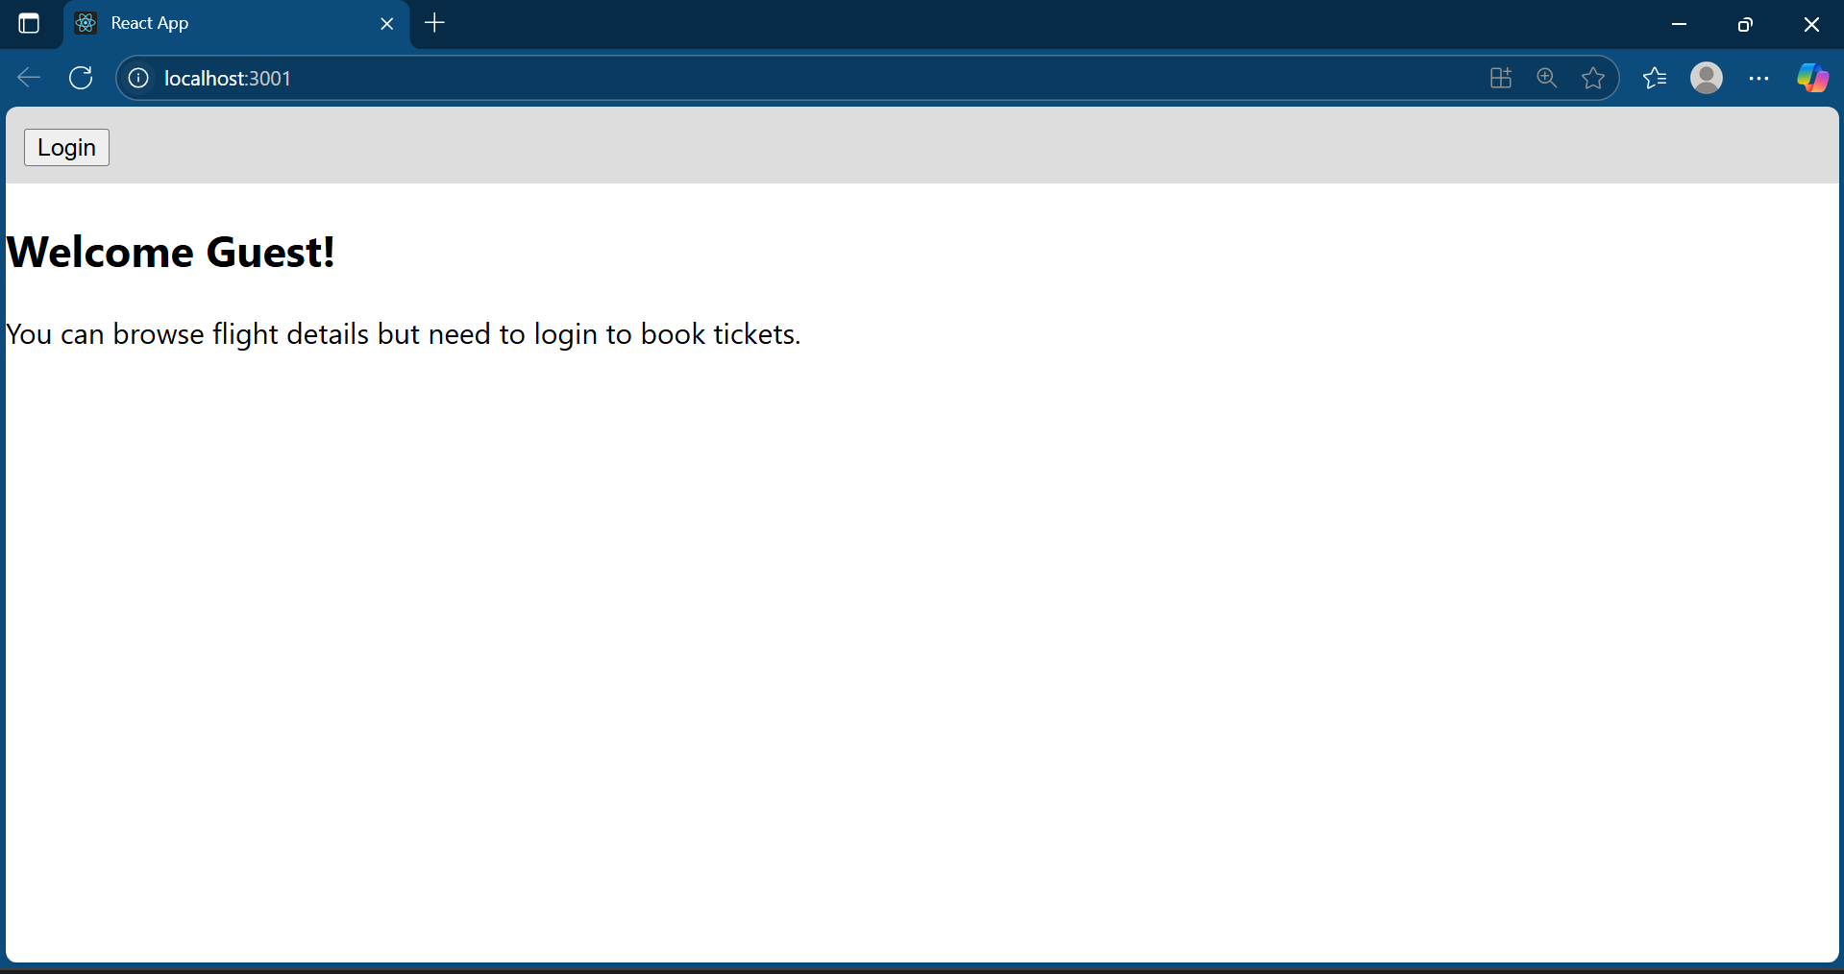

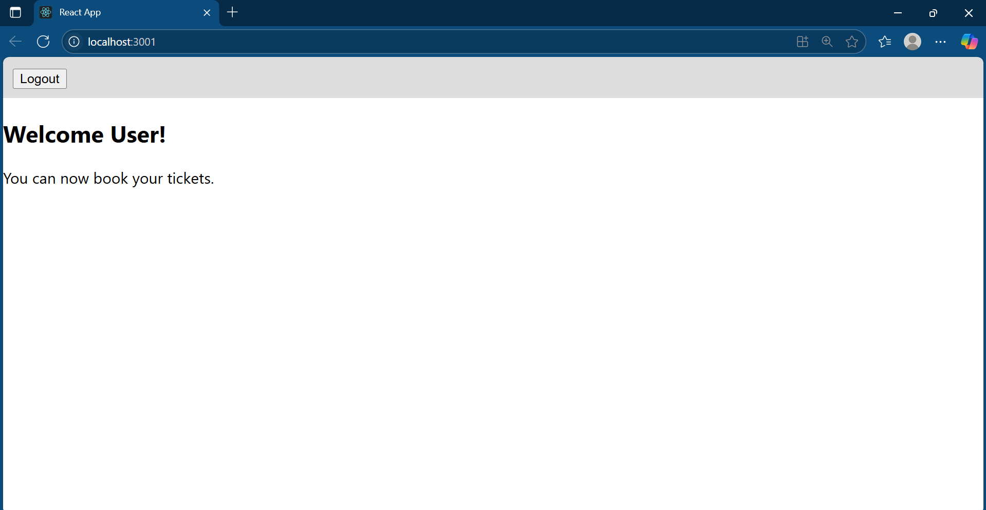**s**